**GIT & INTELLIJ ASSIGNMENT  
  
Name: Jeshma Ullas**  
  
Explain the following questions in two simple sentences

1. What is the use of the git add command?

git add is used to select the files that have been created, modified, or deleted, so they can be included in the next commit.

1. Write the command to create a branch “feature-group”.

git branch feature-group

1. What is a pull request? Write the steps involved in creating a pull request.

Pull request is used to merge the changes made in a feature branch to the main branch in the Git repository.  
  
Steps involved in creating a pull request:

* Push the changes in the feature branch
* Go to “Pull Requests”
* Click “New pull request”
* Click on “Create pull request” and select the branch with changes and the branch to merge into.
* Add a title and description of the changes.
* Submit for review.
* After review, merge the changes to the main branch.

1. How do you add collaborators?

* Go to the repository on GitHub.
* Click on the Settings tab.
* In the sidebar, select Access -> Collaborators.
* Click “Add people”
* Enter the GitHub username or email of the person to be added.
* Click “Add to repository”
* The person will receive an invite they must accept to get access.

1. What is the command used to commit our changes in github repo?

git commit -m “Commit message”

1. Create a github account and repository to save all your assignment tasks. Example repository name: rg-assignments

<https://github.com/Jeshma-Ullas/rg-assignments>

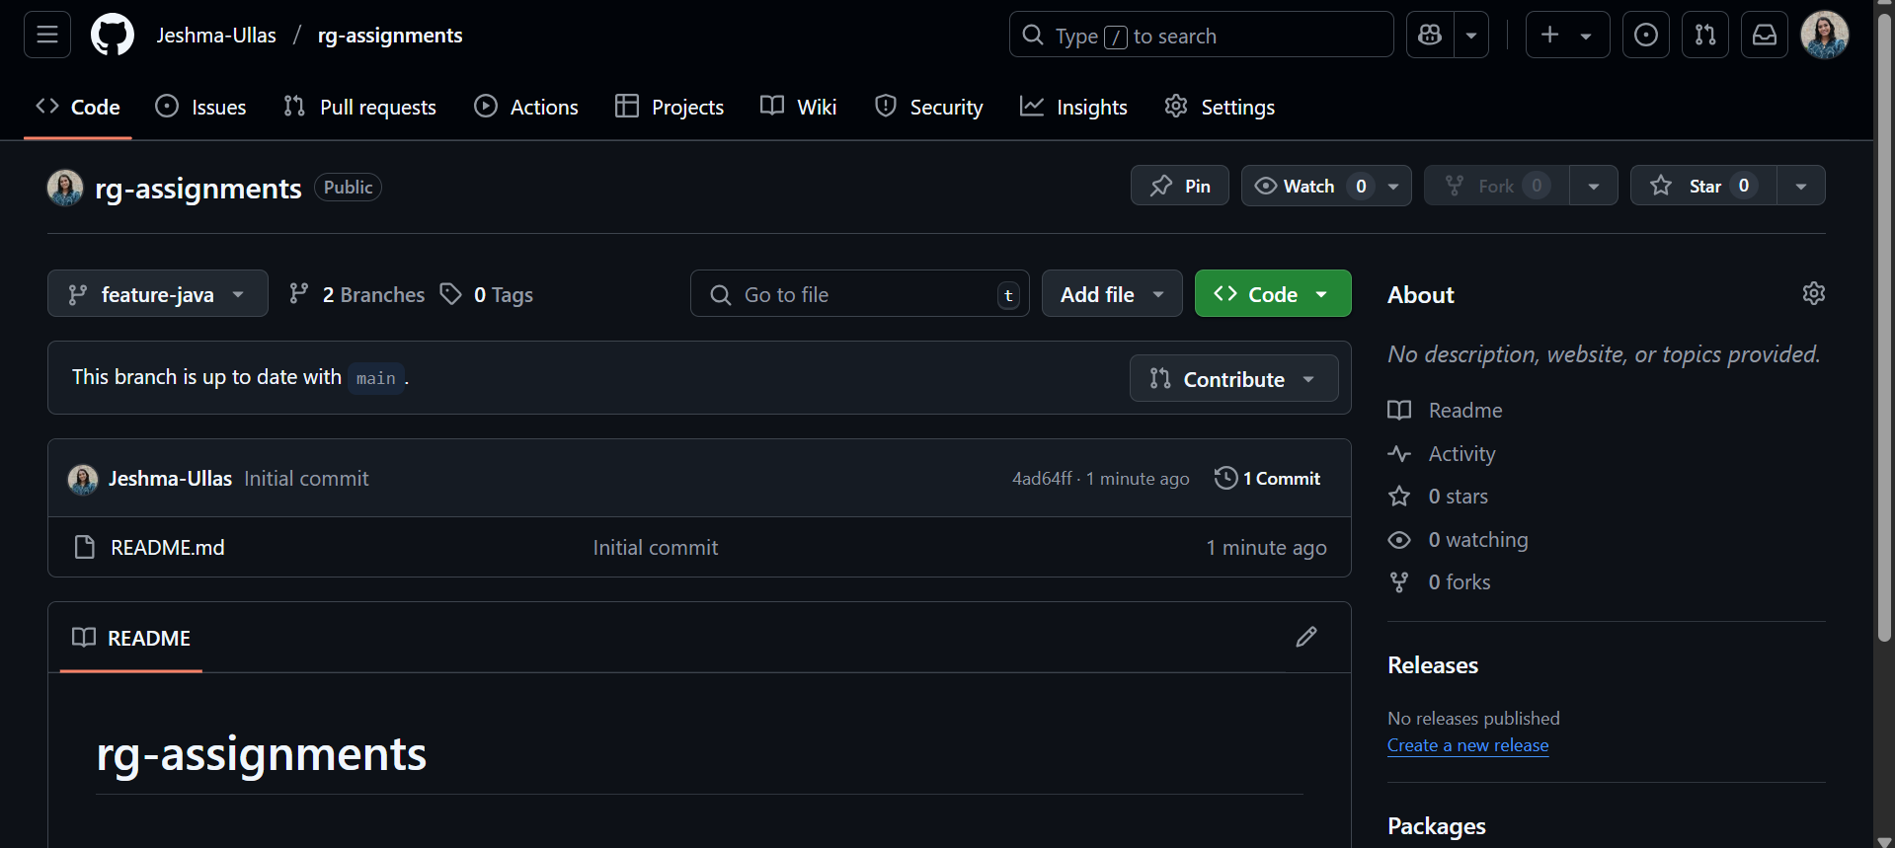

1. Create a branch called feature-java(you can use it later to push all your java related tasks to this branch)

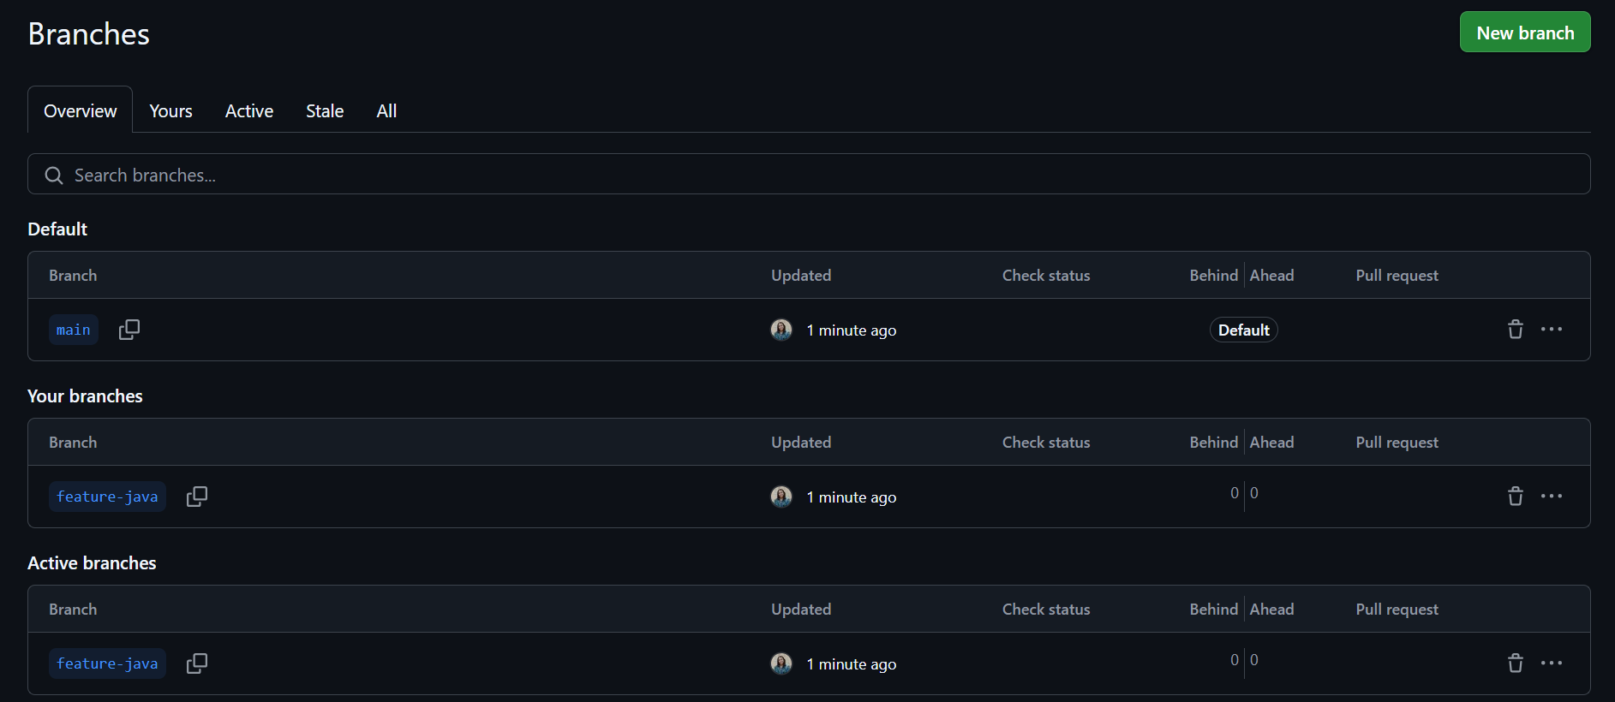

1. Install IntelliJ IDE. Create a simple java project displaying “Hello World!!”and share the screenshot.

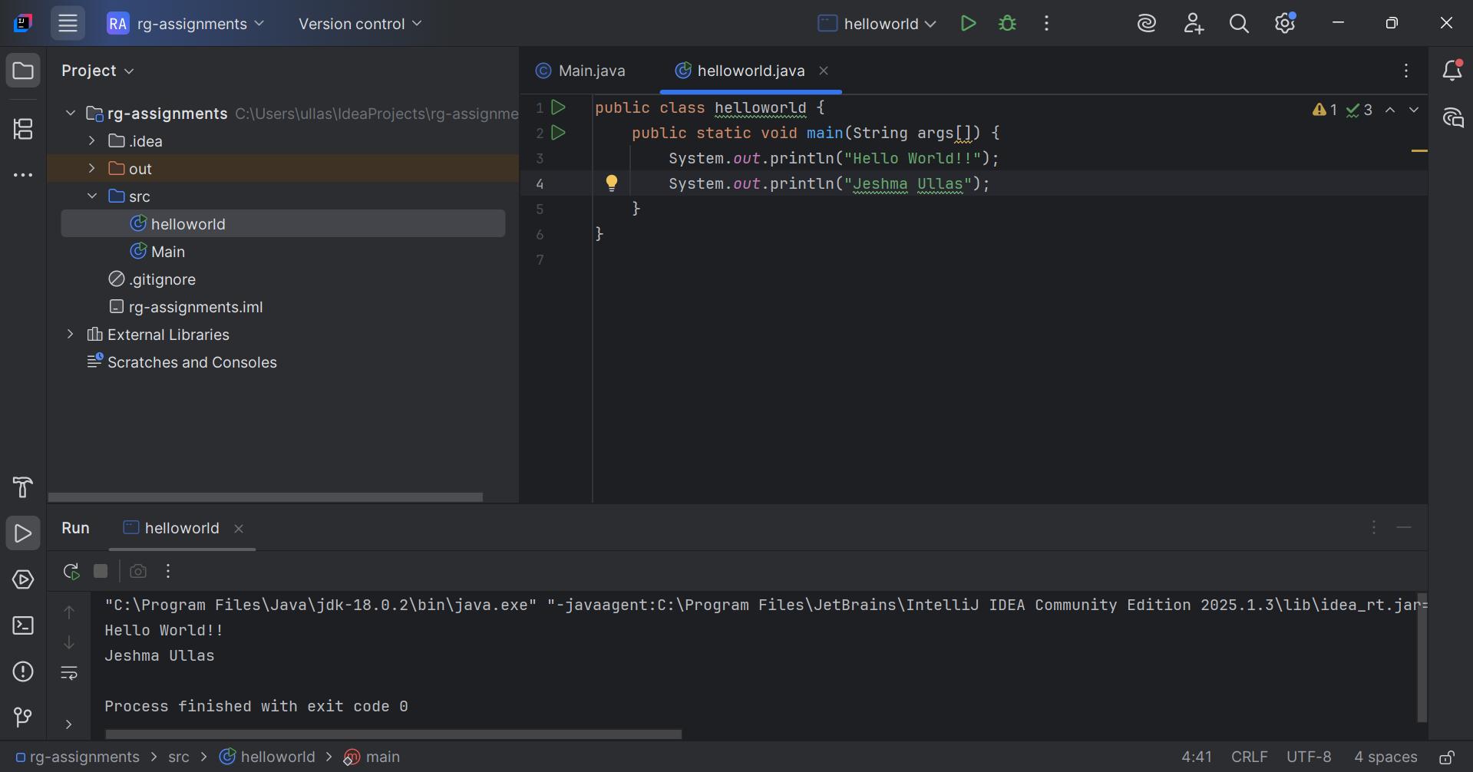

1. In IntelliJ IDE, explore the shortcut keys for the following
   1. To run the project  
      Press Shift + F10 (Windows/Linux) or Control + R (Mac)
   2. To select a line  
      Triple-click the line or use Shift + End (Windows/Linux) or Command + Shift + Right (Mac)
   3. To comment/uncomment a line  
      Use Ctrl + / (Windows/Linux) or Command + / (Mac)
   4. To delete a line  
      Delete a line – Press Ctrl + Y (Windows/Linux) or Command + Delete (Mac)